**Front End Engineering-II**

Project Report

Semester-IV (Batch-2022)

**Zomato Template**



**Supervised By: Submitted By:**

**Raveesh Samkaria Name:- Vaani**

**Roll No:- 2210990930**

**Department of Computer Science and Engineering**

**Chitkara University Institute of Engineering & Technology, Chitkara University, Punjab**

**Abstract:**

* Zomato is an online food delivery and restaurant discovery platform that revolutionises the way people explore and experience dining. With its user-friendly interface and extensive database of restaurants, Zomato simplifies the process of finding and ordering food from a wide range of cuisines and establishments. Users can easily browse through menus, read reviews, and compare ratings to make informed decisions about where to eat.
* Beyond just food delivery, Zomato offers a comprehensive dining experience by providing information about restaurants, including photos, contact details, and operating hours. This allows users to discover new dining spots and plan outings with friends and family effortlessly.
* One of Zomato's key features is its robust review system, where users can share their dining experiences and provide valuable feedback to help others make informed choices. This community-driven approach fosters trust and transparency, ensuring that users can rely on Zomato for accurate and reliable information.The Job Board Platform offers a multifaceted solution by providing an intuitive interface for job seekers to explore diverse job opportunities while enabling employers to showcase their openings effectively. Through innovative features such as advanced search functionalities, personalised job recommendations, and seamless application processes, the platform strives to streamline the job search and hiring processes for both parties.
* Moreover, Zomato's intuitive mobile app and website make ordering food convenient and efficient, with features like real-time tracking and secure payment options. Whether craving comfort food at home or exploring the culinary scene in a new city, Zomato connects users with the best dining options tailored to their preferences.

**Index**

|  |  |  |
| --- | --- | --- |
| Sr.no. | Topics | Page no. |
| 1. | INTRODUCTION | 3-5 |
| 2. | SCOPE | 5-6 |
| 3. | PROBLEM DEFINITION AND REQUIREMENTS | 7-8 |
| 4. | PROPOSED SOLUTION | 8-9 |
| 5. | PURPOSE | 9-10 |
| 6. | SNAPSHOT OF RESULT | 11-12 |

**1.** **Introduction**

Zomato, a pioneering force in the realm of online food delivery and restaurant discovery, has transformed the way people engage with dining experiences. Founded on the principle of connecting food lovers with a diverse array of culinary delights, Zomato has grown into a global platform synonymous with convenience, choice, and community. At its core, Zomato is a digital marketplace that seamlessly bridges the gap between hungry customers and restaurants eager to satisfy their cravings. With an intuitive interface accessible via both web and mobile applications, Zomato empowers users to effortlessly explore an extensive catalog of eateries, ranging from cozy cafes to upscale dining establishments. However, Zomato's appeal extends far beyond mere food delivery. It serves as a comprehensive dining companion, offering users a wealth of information to enhance their culinary adventures. From detailed restaurant profiles complete with menus, photos, and customer reviews to personalized recommendations tailored to individual tastes, Zomato equips users with the tools they need to make informed dining decisions. Central to Zomato's success is its vibrant community of food enthusiasts who actively contribute to the platform's dynamic ecosystem. Through their reviews, ratings, and recommendations, users play an integral role in shaping the dining landscape, fostering a culture of transparency and trust that underpins the Zomato experience. In essence, Zomato is more than just a food delivery service—it's a celebration of culinary diversity, a hub for gastronomic exploration, and a testament to the power of technology to enrich our everyday lives. With its unwavering commitment to innovation and customer satisfaction, Zomato continues to redefine the way we think about food, one delicious bite at a time.

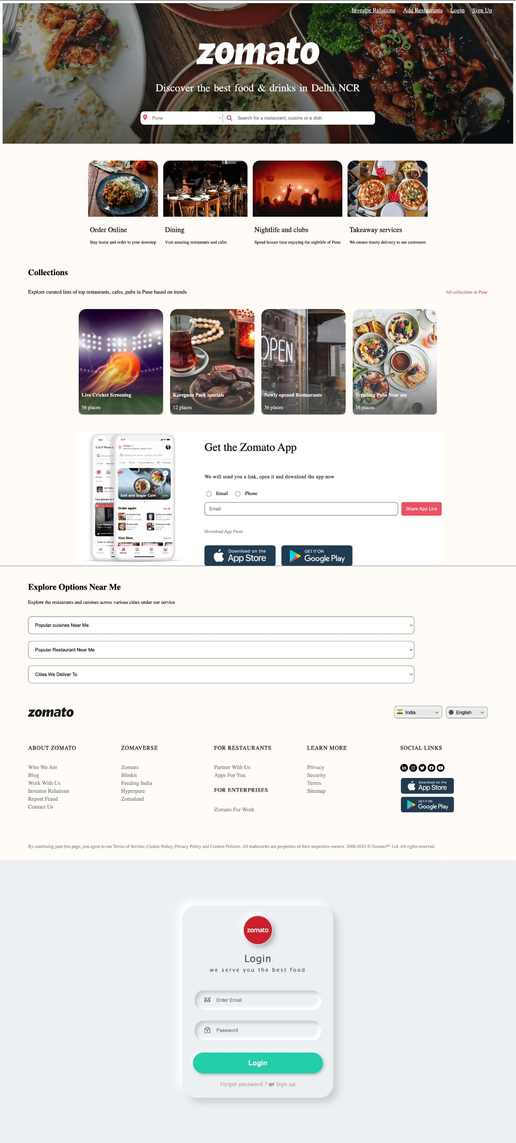

**1.1 Background:**

1. **Evolution of Zomato:** Zomato emerged against the backdrop of a burgeoning digital landscape and shifting consumer preferences in the food industry. Founded in 2008 by Deepinder Goyal and Pankaj Chaddah in India, initially as "Foodiebay," the platform was conceived to address the challenge of accessing comprehensive information about local restaurants and menus online..
2. **Emergence of Online Platforms:** The advent of online food sites has simplified the ordering process, but many platforms lack user-friendly interfaces and comprehensive features.
3. **Addressing Gaps in Existing Solutions:** Recognizing the need for a more streamlined approach, the food ordering Platform seeks to bridge the gap between restuarants and customers, offering a comprehensive solution tailored to their needs.

**1.2 Objectives:**

**1. Enhanced User Experience:** Develop a user-friendly interface that simplifies the food search process, making it intuitive and efficient for food ordering cutomers.

**2.** **Comprehensive Job Listings:** Curate a diverse range of restaurants openings across cities and locations to cater to the varying needs of food.

**3.** **Efficient Recruitment Process:** Provide employers with tools to post food listings, manage applications, and identify suitable meals effectively.

**4. Personalized Recommendations:** Implement algorithms to analyze user preferences and provide personalized recommendations, enhancing the relevance of food search.

**1.3 Significance:**

1. **Convenience**: Zomato has revolutionized the way people order food by providing a convenient platform for browsing menus, reading reviews, and placing orders from a diverse range of restaurants. This convenience has made it easier for consumers to explore new cuisines, discover hidden gems, and satisfy their cravings without leaving their homes.
2. **Accessibility**: Zomato has democratized access to information about local restaurants, making it easier for consumers to discover dining options that suit their preferences and dietary requirements. Whether searching for vegetarian-friendly eateries or gluten-free options, users can rely on Zomato to find restaurants that cater to their needs.
3. **Transparency**: Through its user-generated review system, Zomato promotes transparency and accountability in the dining industry. By allowing customers to share their experiences and provide feedback, Zomato helps others make informed decisions about where to eat, fostering a culture of trust and reliability.
4. **Global Reach**: With its presence in multiple countries around the world, Zomato has become a global platform for food discovery and delivery. This global reach not only exposes users to a diverse array of cuisines but also facilitates cultural exchange and appreciation through food.
5. **Innovation**: Zomato continuously innovates to enhance the dining experience for its users. From real-time order tracking to personalized recommendations, Zomato leverages technology to improve convenience, efficiency, and satisfaction for both customers and restaurant partners.

**2.Scope**

1. **Food Delivery**: Zomato's primary scope lies in food delivery, offering users a convenient platform to order food from a wide range of restaurants. This includes everything from local eateries to popular chains, covering various cuisines and dietary preferences.
2. **Restaurant Discovery**: Zomato serves as a comprehensive restaurant discovery platform, allowing users to explore and discover new dining options based on location, cuisine, price range, and user reviews. This aspect of Zomato's scope is essential for users looking to try new restaurants or find specific types of cuisine.
3. **Reviews and Ratings**: Zomato provides a platform for users to share their dining experiences through reviews and ratings. This user-generated content is integral to Zomato's scope as it helps other users make informed decisions about where to eat and contributes to the overall transparency and trustworthiness of the platform.
4. **Table Reservations**: Zomato offers table reservation services at select restaurants, allowing users to book tables in advance for dining out. This feature expands Zomato's scope beyond food delivery and enhances its value proposition as a one-stop destination for all dining-related needs.
5. **Event Booking**: Zomato enables users to book events such as food festivals, tastings, and culinary workshops through its platform. This aspect of Zomato's scope caters to users interested in exploring food-related events and experiences beyond traditional dining.
6. **Curated Experiences**: Zomato curates dining experiences and offers recommendations tailored to individual preferences, helping users discover new restaurants and dishes based on their past behavior and preferences. This personalized approach enhances the user experience and adds depth to Zomato's scope.
7. **Global Expansion**: Zomato's scope extends globally, with a presence in multiple countries and regions around the world. This global expansion broadens Zomato's reach and allows it to cater to diverse cultures and culinary preferences.

Overall, the scope of Zomato encompasses various aspects of the dining experience, including food delivery, restaurant discovery, reviews and ratings, table reservations, event booking, curated experiences, and global expansion. As Zomato continues to innovate and grow, its scope will likely evolve to encompass new services and features that enhance the overall dining experience for users.

**3.Problem definition and Requirements :-**

**3.1 Problem Definition**

The traditional methods of food site and recruitment often lack efficiency and fail to provide a seamless experience for customers. There is a need for a comprehensive food board platform that addresses the limitations of existing solutions and streamlines the ordering process.

**3.2 Hardware Requirements**

1. **Operating System:** Zomato's backend servers may run on various operating systems, commonly Linux distributions like Ubuntu, CentOS, or others.
2. **Web Server:** Zomato may use web servers like Nginx, Apache, or others to serve web pages to users.
3. **Database:** For storing data, Zomato likely uses a relational database management system (RDBMS) such as MySQL, PostgreSQL, or a NoSQL database like MongoDB.
4. **Programming Language:** Zomato's backend logic is likely written in a server-side language such as Python, Java, Ruby, or Node.js.
5. **Framework:** Depending on the language used, Zomato may utilize web frameworks like Django (Python), Spring (Java), Ruby on Rails (Ruby), or Express.js (Node.js) to streamline development.
6. **Caching:** To improve performance, Zomato may use caching solutions like Redis or Memcached to store frequently accessed data in memory.

**3.3 Software Requirements**

1. **Security**: Zomato employs various security measures to protect user data, including encryption (HTTPS), secure authentication mechanisms, and regular security audits.
2. **Scalability**: Zomato's infrastructure is designed to handle large volumes of traffic, with scalability features such as load balancing, auto-scaling, and distributed architecture.
3. **Monitoring and Analytics**: Zomato likely uses monitoring tools and analytics platforms to track website performance, user behavior, and other metrics for optimization and decision-making.

**4. Proposed solution**

* **User Interface Design:** Create a visually appealing and intuitive user interface (UI) that enhances the overall user experience. Prioritize mobile responsiveness to ensure seamless access and usability across devices of all sizes Implement clear navigation and intuitive layout to facilitate easy browsing of restaurants, menus, reviews, and other features.
* **Restaurant Discovery and Search:**Develop robust search functionality allowing users to search for restaurants based on location, cuisine, price range, ratings, and other filters.Implement geolocation services to provide personalized recommendations and nearby restaurant suggestions.Incorporate advanced filtering options to cater to diverse user preferences and dietary requirements.
* **User Registration and Authentication:**Enable user registration and authentication mechanisms to personalize the user experience, save preferences, and track order history.Implement secure authentication methods such as email/password login, social media integration, or two-factor authentication for enhanced security.
* **Restaurant Listings and Profiles:** Create detailed restaurant profiles featuring essential information such as menus, pricing, operating hours, contact details, and user-generated reviews and ratings. Enable restaurant owners to claim and manage their profiles, update information, and respond to customer reviews.
* **Ordering and Delivery:** Integrate a seamless ordering and checkout process allowing users to add items to their cart, customize orders, and choose delivery or pickup options. Implement real-time order tracking functionality to provide users with updates on the status of their orders and estimated delivery times. Collaborate with delivery partners or establish an in-house delivery fleet to ensure efficient and timely order fulfillment.
* **Reviews and Ratings System:** Develop a robust reviews and ratings system enabling users to share their dining experiences, rate restaurants, and leave feedback. Implement moderation mechanisms to ensure the authenticity and credibility of user-generated content, while also allowing constructive criticism.
* **Admin Panel and Analytics:** Build an administrative dashboard to manage restaurant listings, user accounts, orders, payments, and other platform activities. Incorporate analytics tools to track user engagement, website traffic, order metrics, and other key performance indicators for data-driven decision-making and optimization.
* **Scalability and Performance:** Design a scalable architecture capable of handling high traffic volumes and accommodating future growth. Utilize cloud infrastructure, load balancing, caching mechanisms, and other optimization techniques to ensure optimal performance and reliability.
* **Security and Compliance:** Implement robust security measures to protect user data, payment transactions, and sensitive information against unauthorized access, breaches, and cyber threats. Ensure compliance with data protection regulations such as GDPR, CCPA, and PCI-DSS to safeguard user privacy and maintain trust.

**5.Purpose**

1. **Restaurant Discovery**: Zomato serves as a platform for users to discover new restaurants, cafes, eateries, and food outlets in their vicinity or in any location they're interested in. Users can explore a wide range of dining options based on cuisine, price range, ratings, and reviews.
2. **Food Ordering and Delivery**: Zomato allows users to conveniently order food for delivery or pickup from a variety of restaurants listed on the platform. Users can browse menus, customize orders, and track delivery in real-time, making the food ordering process seamless and efficient.
3. **User Reviews and Ratings**: Zomato provides a platform for users to share their dining experiences through reviews and ratings. These user-generated reviews help others make informed decisions about where to eat and contribute to a transparent and trustworthy dining community.
4. **Restaurant Management**: For restaurants and food businesses, Zomato offers tools and services to manage their online presence, including creating and updating restaurant profiles, managing menus, responding to reviews, and tracking performance metrics.
5. **Table Reservations**: Zomato enables users to make table reservations at select restaurants, allowing them to secure a dining experience in advance and avoid waiting times, especially during peak hours.

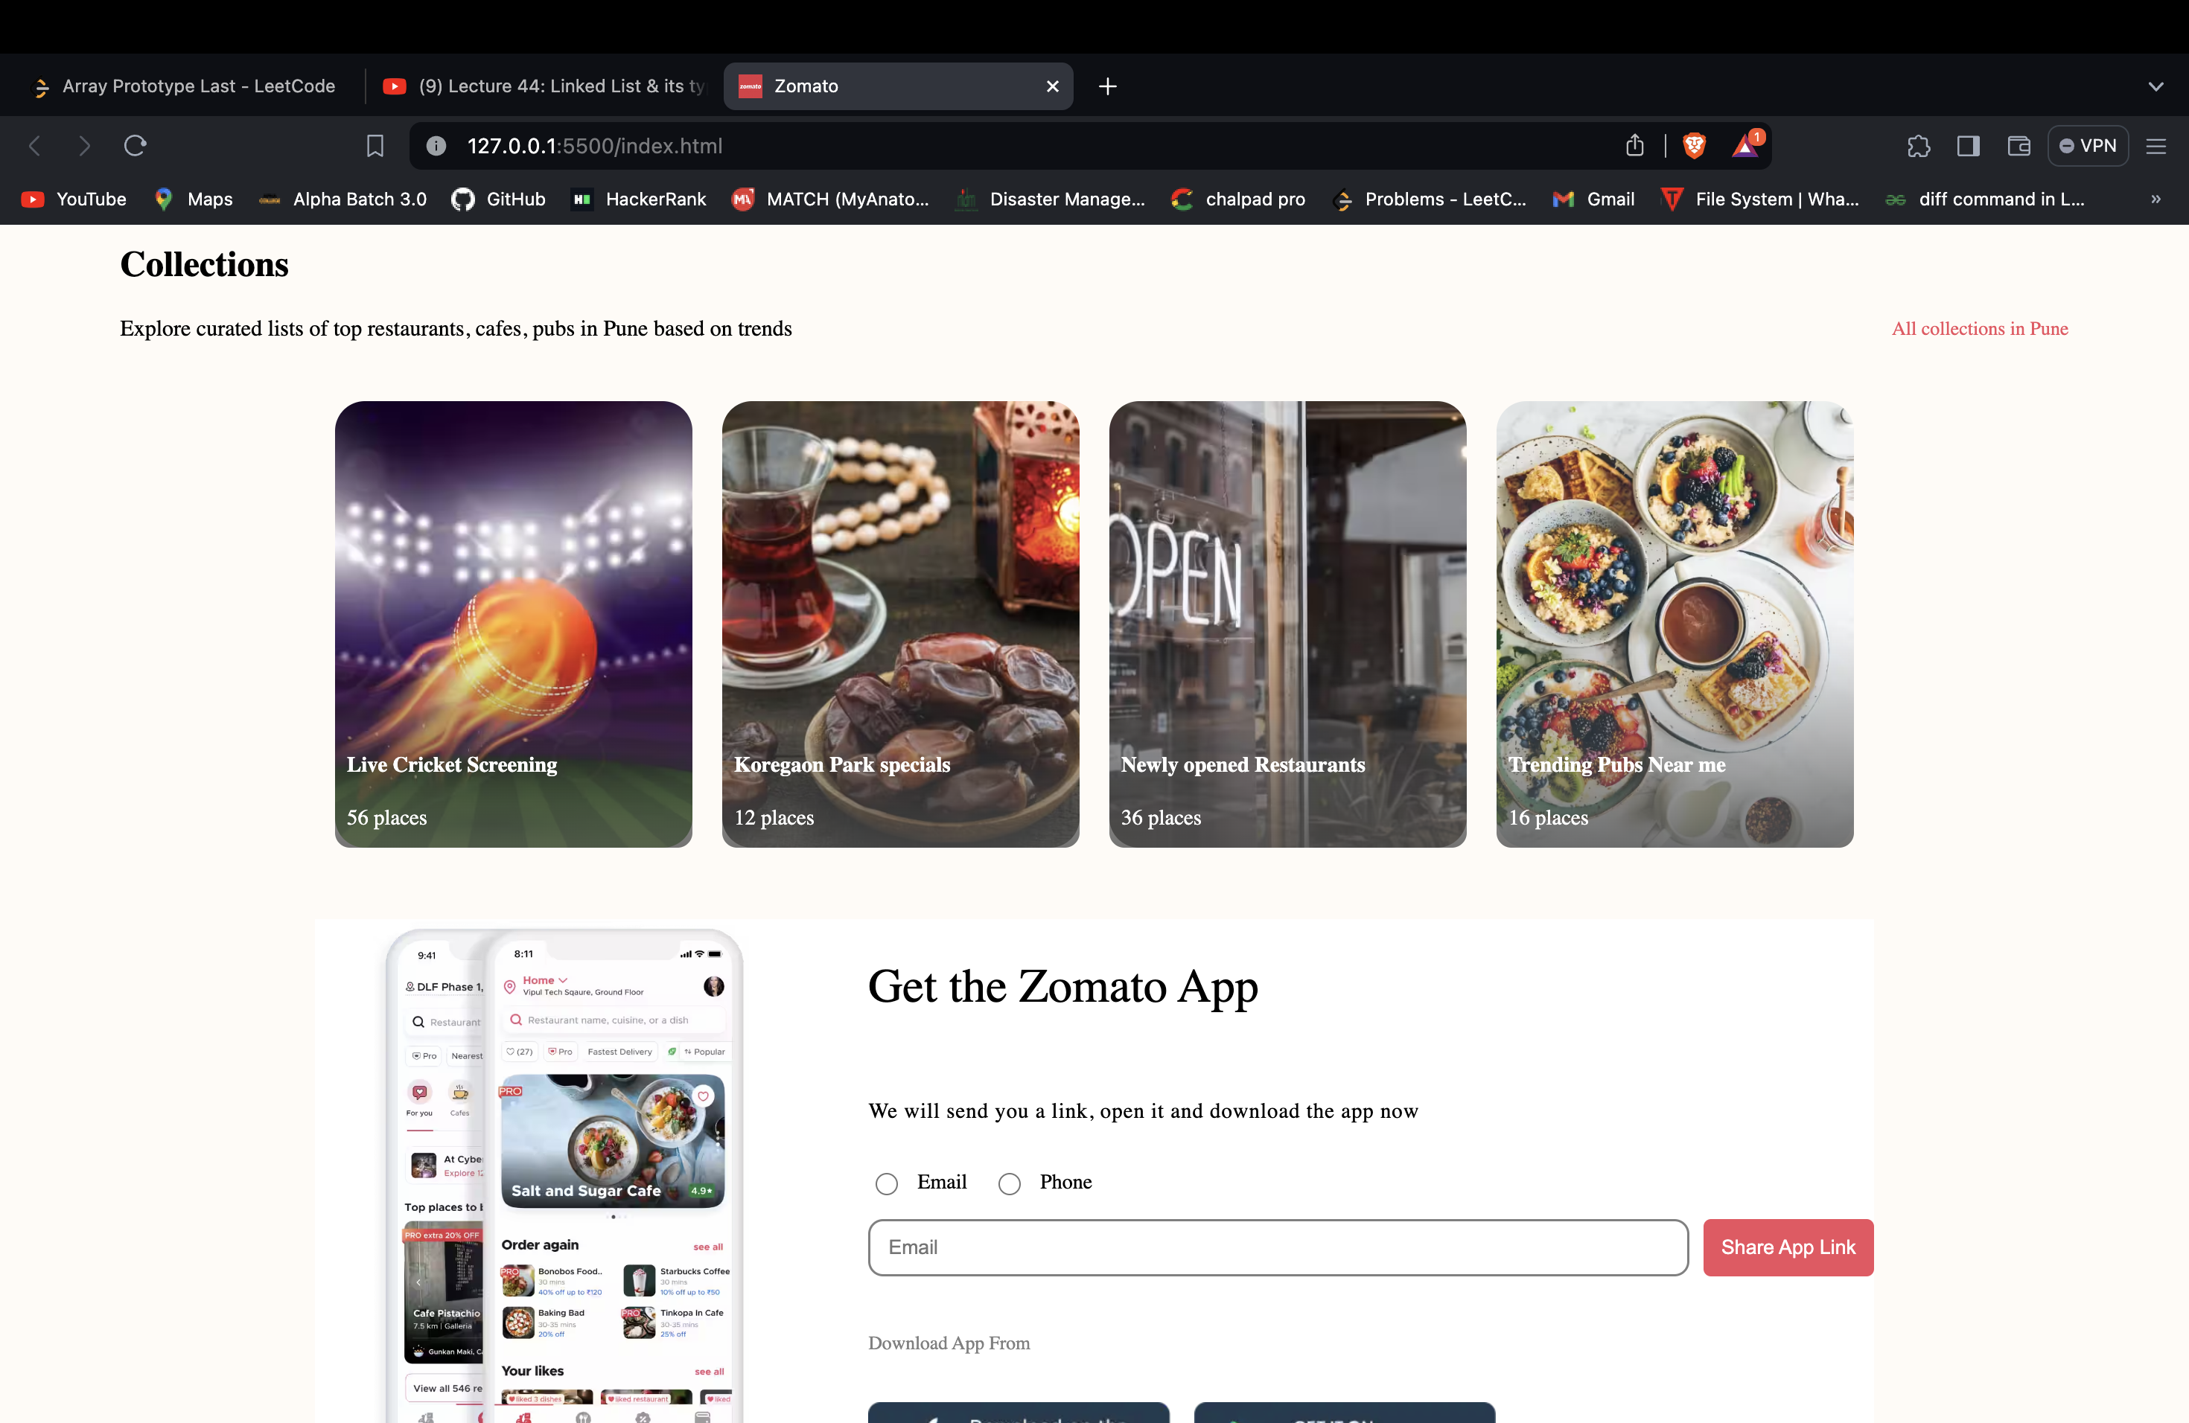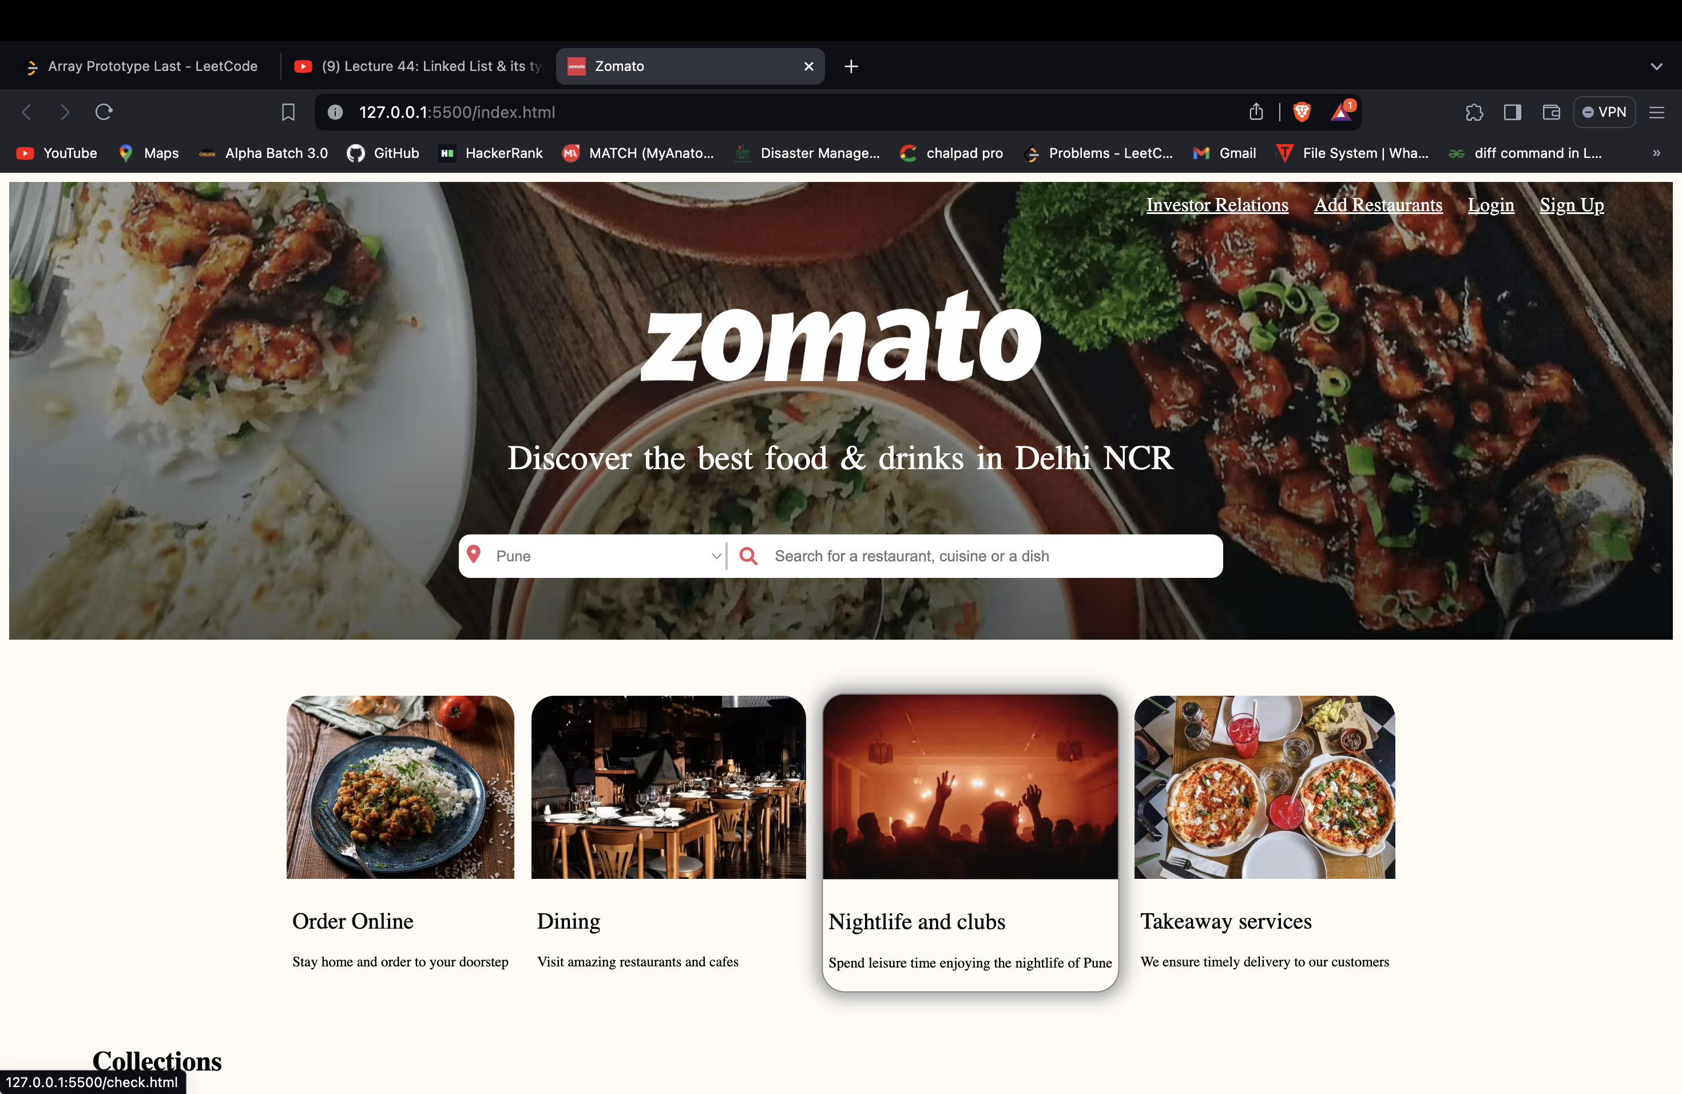**6.Snapshots Of Zomato**

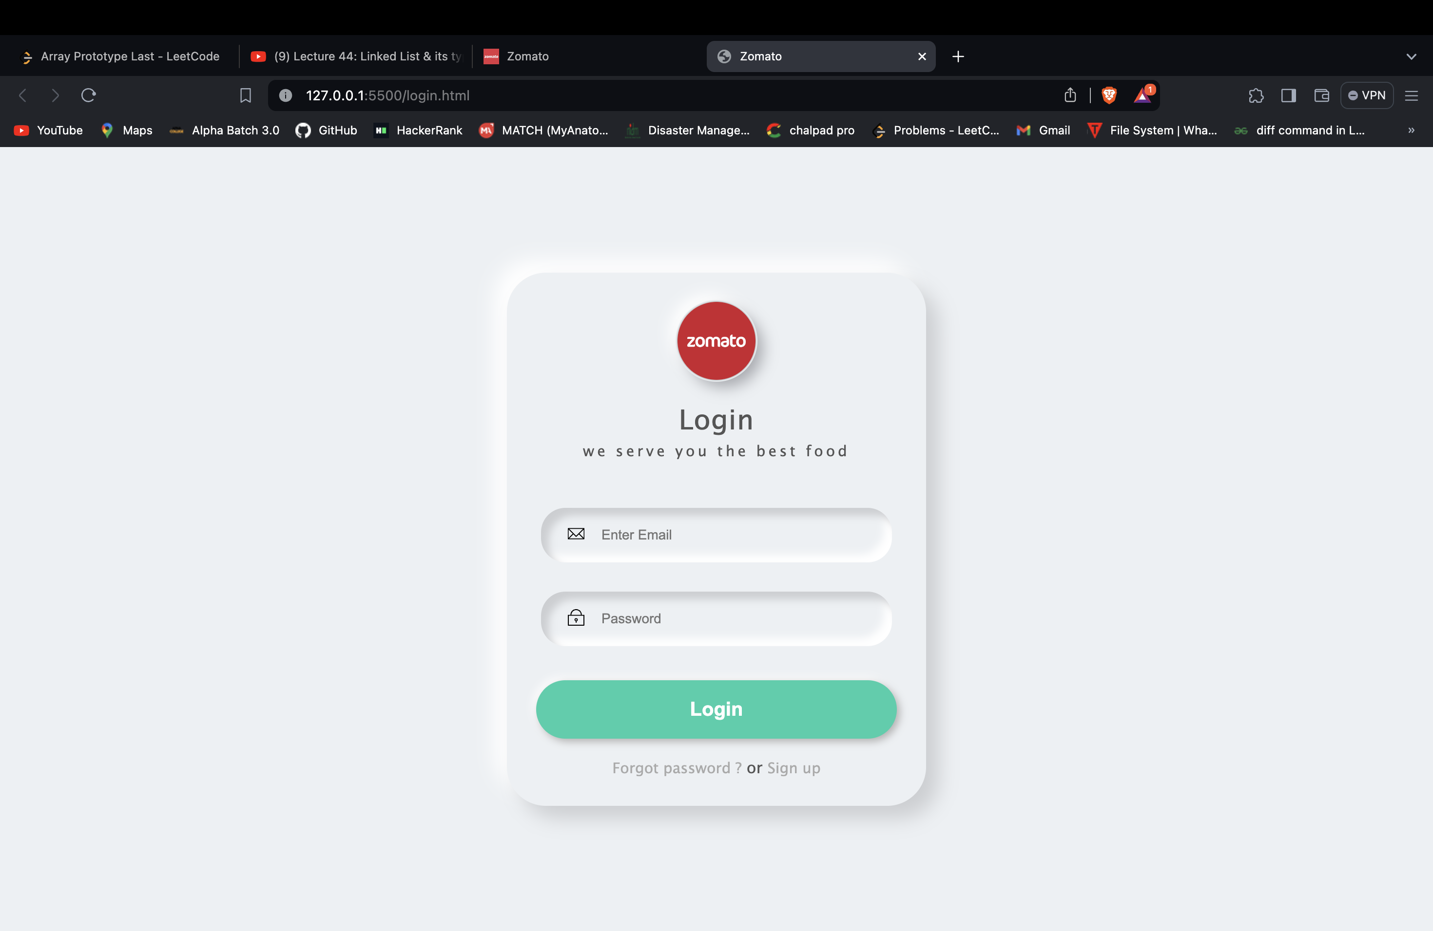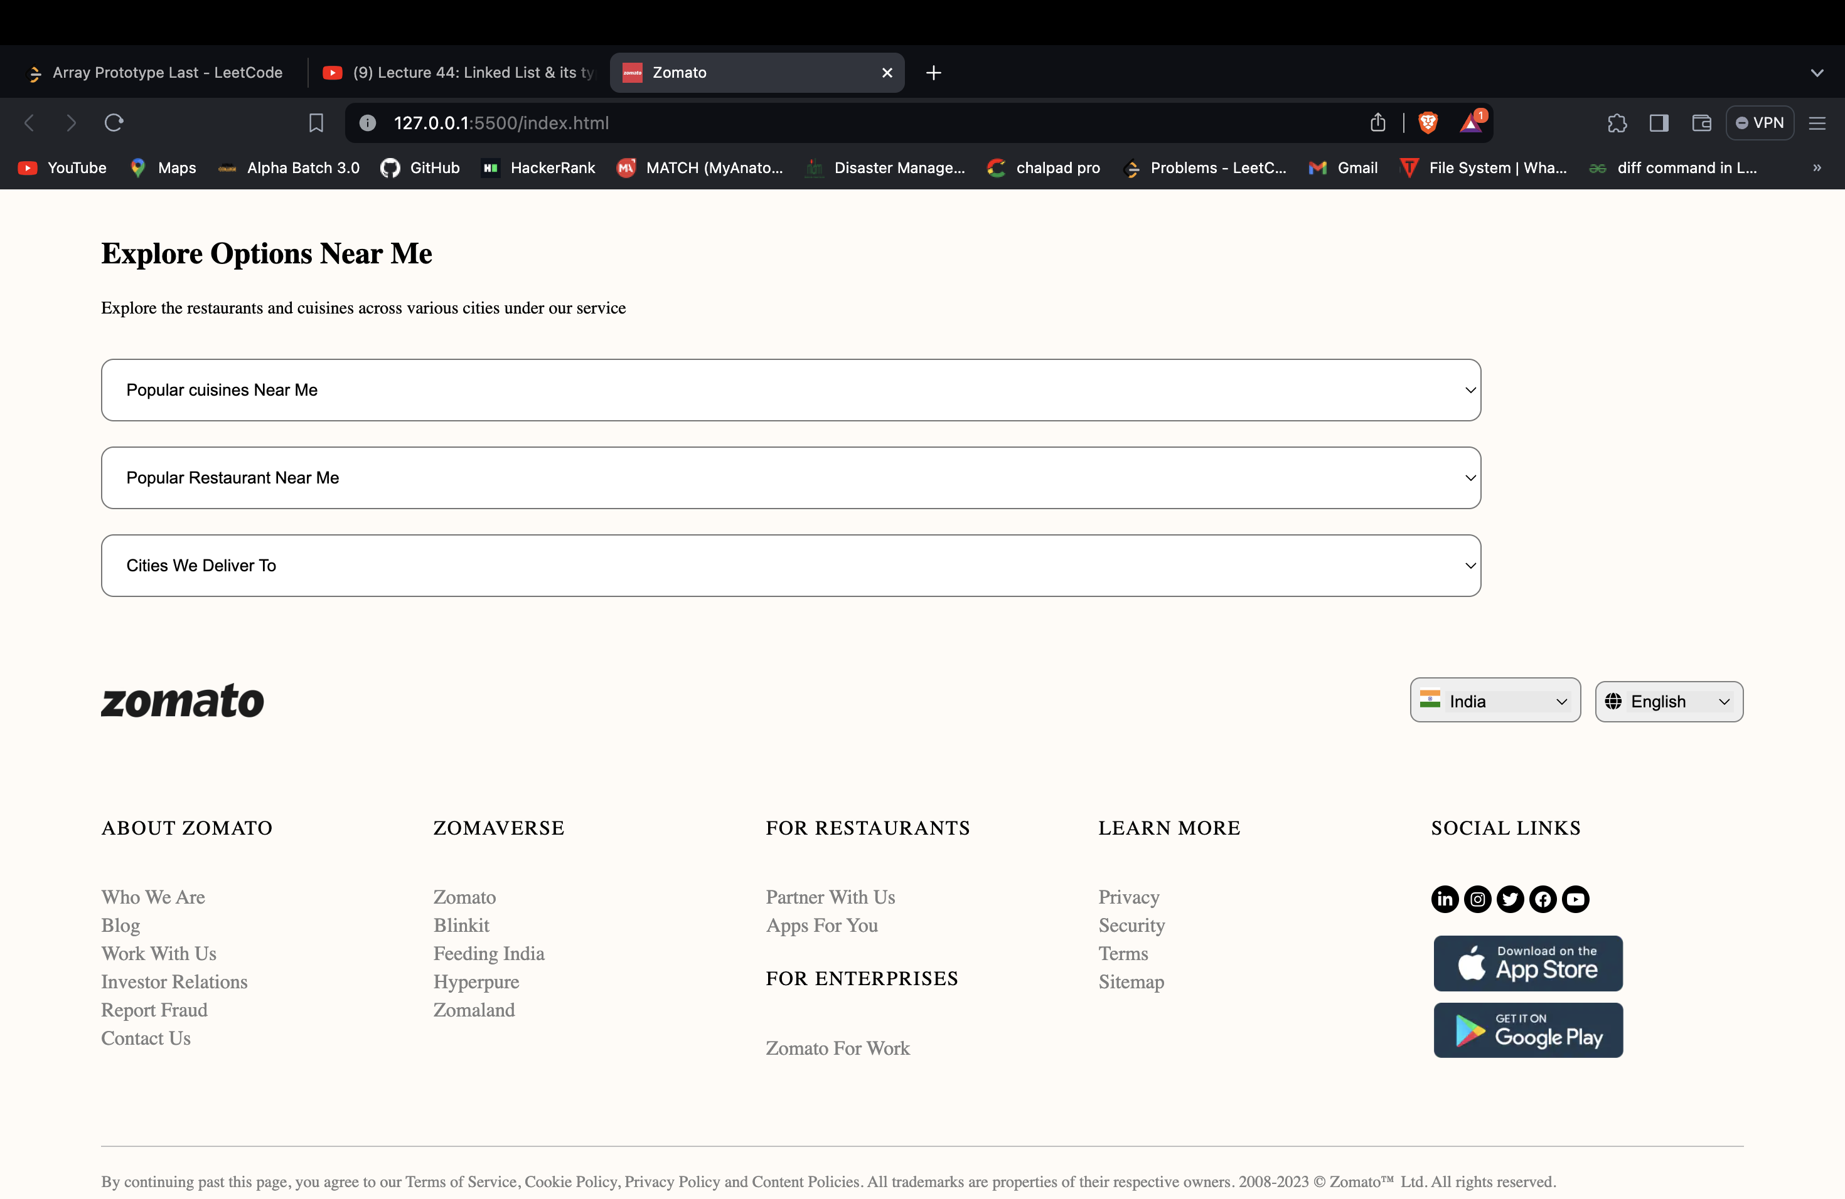

**7. Code:-**

**7.1 Index file:-**

<!DOCTYPE html>

<html>

<head>

<meta charset="UTF-8">

<meta name="viewport" content="width=device-width, initial-scale=1.0">

<meta http-equiv="X-UA-Compatible" content="ie=edge">

<link

rel = "icon"

href = "./Images/ZomatoLogo.jpg";

/>

<link

rel = "stylesheet"

href = "https://cdnjs.cloudflare.com/ajax/libs/font-awesome/6.1.1/css/all.min.css"

integrity = "sha512-KfkfwYDsLkIlwQp6LFnl8zNdLGxu9YAA1QvwINks4PhcElQSvqcyVLLD9aMhXd13uQjoXtEKNosOWaZqXgel0g=="

crossorigin = "anonymous"

referrerpolicy = "no-referrer"

/>

<link rel="preconnect" href="https://fonts.googleapis.com" />

<link rel="preconnect" href="https://fonts.gstatic.com" crossorigin />

<link

rel="stylesheet"

href="https://fonts.googleapis.com/css2?family=Poppins:ital,wght@0,100;0,200;0,300;0,400;0,500;0,600;0,700;0,800;0,900;1,100;1,200;1,300;1,400;1,500;1,600;1,700;1,800;1,900&display=swap"

/>

<link rel = "stylesheet" href = "./styles.css" />

<title>Zomato</title>

</head>

<body>

<section class = "hero__section">

<header>

<nav class = "navbar">

<a href = "#"></a>

<div class = "navbar__menu_container">

<a href = "#" class = "link" >Investor Relations</a>

<a href = "#" class = "link" >Add Restaurants</a>

<a href = "login.html" class = "link" target="_blank">Login</a>

<a href = "signup.html" class = "link"target="_blank">Sign Up</a>

<a href = "#" class = "user_icon"><i class="fa-solid fa-user"></i></a>

</div>

</nav>

</header>

<div class = "hero__section_container">

<img src = "./Images/heroSectionLogo.png" alt = "Zomato Logo" class = "hero__section_logo" />

<h1 class = "hero__section_heading">Discover the best food & drinks in Delhi NCR</h1>

<div class = "hero__section_container_input">

<i class="fa-sharp fa-solid fa-location-dot" id = "location_icon"></i>

<select class = "hero__section_input_location">

<option>Pune</option>

<option>Mumbai</option>

<option>Banglore</option>

<option>Delhi</option>

</select>

<i class="fa-solid fa-magnifying-glass" id = "search_icon"></i>

<input class = "hero__section_input_search" type = "text" placeholder = "Search for a restaurant, cuisine or a dish" />

</div>

</div>

</section>

<section class = "container_cards">

<div class = "we_offer__cards">

<a href="check.html">

<img src = "./Images/item1.png" alt = "card1 image"/></a>

<div class = "we_offer__cards_content">

<h2>Order Online</h2>

<p>Stay home and order to your doorstep</p>

</div>

</div>

<div class = "we_offer__cards">

<a href="check.html">

<img src = "./Images/item2.png" alt = "card1 image"/></a>

<div class = "we_offer__cards_content">

<h2>Dining</h2>

<p>Visit amazing restaurants and cafes</p>

</div>

</div>

<div class = "we_offer__cards">

<a href="check.html">

<img src = "./Images/item3.png" alt = "card1 image"/></a>

<div class = "we_offer__cards_content">

<h2>Nightlife and clubs</h2>

<p>Spend leisure time enjoying the nightlife of Pune</p>

</div>

</div>

<div class = "we_offer__cards">

<a href="check.html">

<img src = "./Images/item4.png" alt = "card1 image"/></a>

<div class = "we_offer__cards_content">

<h2>Takeaway services</h2>

<p>We ensure timely delivery to our customers</p>

</div>

</div>

</section>

<section class = "container_collections">

<h1>Collections</h1>

<div class = "sub_heading__container">

<span>Explore curated lists of top restaurants, cafes, pubs in Pune based on trends</span>

<span id = "span">All collections in Pune</span>

</div>

<div class = "collections__cards_container">

<div class = "cards card1">

<div class = "overlay"></div>

<div class = "collections__content">

<h4>Live Cricket Screening</h4>

<span>56 places</span>

</div>

</div>

<div class = "cards card2">

<div class = "overlay"></div>

<div class = "collections__content">

<h4>Koregaon Park specials</h4>

<span>12 places</span>

</div>

</div>

<div class = "cards card3">

<div class = "overlay"></div>

<div class = "collections__content">

<h4>Newly opened Restaurants</h4>

<span>36 places</span>

</div>

</div>

<div class = "cards card4">

<div class = "overlay"></div>

<div class = "collections__content">

<h4>Trending Pubs Near me</h4>

<span>16 places</span>

</div>

</div>

</div>

</section>

<section class = "container__get_the_App">

<div class = "semi_container">

<div class = "semi_container__left">

<img src = "./Images/mobileBanner.png" alt = "mobile image" />

</div>

<div class = "semi_container__right">

<h1>Get the Zomato App</h1>

<p>We will send you a link, open it and download the app now</p>

<div class = "radio_button__container">

<div>

<input type = "radio" id = "email" name = "downloadApp" />

<label for = "email" style = "font-size:14px;">Email</label>

</div>

<div>

<input type = "radio" id = "phone" name = "downloadApp" />

<label for = "phone" style = "font-size:14px;">Phone</label>

</div>

</div>

<div class = "input__container">

<input type = "text" placeholder = "Email" />

<button>Share App Link</button>

</div>

<div class = "download_app__container">

<h5>Download App From</h5>

<div>

<img src = "./Images/appleStore.png" alt = "Apple store" />

<img src = "./Images/playStore.png" alt = "Play store" />

</div>

</div>

</div>

</div>

</section>

<section class = "explore_places__container">

<div class = "sub_container">

<div>

<h1>Explore Options Near Me</h1>

<span>Explore the restaurants and cuisines across various cities under our service</span>

</div>

<div class = "drop_down__container">

<div>

<select class = "drop_down_menu">

<option>Popular cuisines Near Me</option>

<option>Open Window Cafe Bistro</option>

<option>Gauri's Kitchen</option>

<option>Food Moments</option>

<option>Senses - Marriott Suites Pune</option>

</select>

</div>

<div>

<select class = "drop_down_menu">

<option>Popular Restaurant Near Me</option>

<option>Trishna Resto And Bar</option>

<option>Pimlico</option>

<option>Green Thing</option>

<option>Kava Kitchen</option>

</select>

</div>

<div>

<select class = "drop_down_menu">

<option>Cities We Deliver To</option>

<option>Pune</option>

<option>Mumbai</option>

<option>Banglore</option>

<option>Delhi</option>

</select>

</div>

</div>

</div>

</section>

<footer class = "footer__container">

<div class = "footer_section1">

<img src = "./Images/logo.png" alt = "zomato logo" />

<div class = "section1__button_container">

<button>

<img src = "./Images/IndianFlag.png" alt = "Indian Flag" style = "width: 16px; height: 16px" />

<select style = "border: none; background: #e8e8e8; cursor: pointer">

<option>India</option>

<option>United States</option>

<option>Australia</option>

<option>New Zealand</option>

<option>Spain</option>

<option>England</option>

</select>

</button>

<button>

<i class = "fa fa-globe"></i>

<select style = "border: none; background: #e8e8e8; cursor: pointer">

<option>English</option>

<option>Español</option>

<option>Čeština</option>

<option>Slovenčina</option>

<option>Polish</option>

<option>Italian</option>

</select>

</button>

</div>

</div>

<div class = "navigation_container">

<div class = "link_container">

<h5>About Zomato</h5>

<div class = "link_container_anchors">

<a href = "#">Who We Are</a>

<a href = "#">Blog</a>

<a href = "#">Work With Us</a>

<a href = "#">Investor Relations</a>

<a href = "#">Report Fraud</a>

<a href = "#">Contact Us</a>

</div>

</div>

<div class = "link_container">

<h5>Zomaverse</h5>

<div class = "link_container_anchors">

<a href = "#">Zomato</a>

<a href = "#">Blinkit</a>

<a href = "#">Feeding India</a>

<a href = "#">Hyperpure</a>

<a href = "#">Zomaland</a>

</div>

</div>

<div class = "link_container">

<h5>For Restaurants</h5>

<div class = "link_container_anchors">

<a href = "#">Partner With Us</a>

<a href = "#">Apps For You</a>

</div>

<h5 id = "enterprises">For Enterprises</h5>

<div class = "link_container_anchors">

<a href = "#">Zomato For Work</a>

</div>

</div>

<div class = "link_container">

<h5>Learn More</h5>

<div class = "link_container_anchors">

<a href = "#">Privacy</a>

<a href = "#">Security</a>

<a href = "#">Terms</a>

<a href = "#">Sitemap</a>

</div>

</div>

<div class = "link_container">

<h5>Social Links</h5>

<div class = "social_media_icon_buttons">

<button><i class="fa-brands fa-linkedin-in"></i> </button>

<button><i class = "fa-brands fa-instagram"></i></button>

<button><i class = "fa-brands fa-twitter"></i></button>

<button><i class = "fa-brands fa-facebook"></i></button>

<button><i class = "fa-brands fa-youtube"></i></button>

<div class = "social_media_logos">

<img src = "./Images/appleStore.png" alt = "Apple store" />

<img src = "./Images/playStore.png" alt = "Play store" id = "img2"/>

</div>

</div>

</div>

</div>

<div class = "disclaimer">

By continuing past this page, you agree to our Terms of Service, Cookie Policy,

Privacy Policy and Content Policies. All trademarks are properties of their respective owners.

2008-2023 © Zomato™ Ltd. All rights reserved.

</div>

</footer>

</body>

</html>